INNOLOFT VENTURES | InnoTrack Daily Report | 20-Day Internship Program

DAILY INTERNSHIP REPORT
Submit this report on InnoTrack by 5:00 PM every day
SECTION 1 — STUDENT INFORMATION

Student Name | R TARUN | VTU ID | 28753
Branch / Dept. | B.Tech CSE | Internship Day No. | 06
Date | 06/06/2026 | Track (1 / 2 / 3 / 4) | 2
Project Title | Smart Crop Recommendation Engine - Agriculture | Mentor Name | Akhil

SECTION 2 — WHAT DID YOU LEARN TODAY?

Topic / Concept Learned (e.g. Random Forest, Flask routing, model saving...)
Logistic Regression vs Decision Tree vs KNN

Random Forest & SVM Overview

Accuracy, Precision, Recall & F1-Score

SECTION 3 — WHAT DID YOU BUILD TODAY?

Code / Output / Feature Built (e.g. Built EDA section, trained model, created Flask form...)
We built a Crop Recommendation System using Logistic Regression, Decision Tree, and Random Forest algorithms to predict suitable crops from agricultural data. Logistic Regression was used as the baseline model because it is simple, fast, and provides a benchmark for comparing other models.
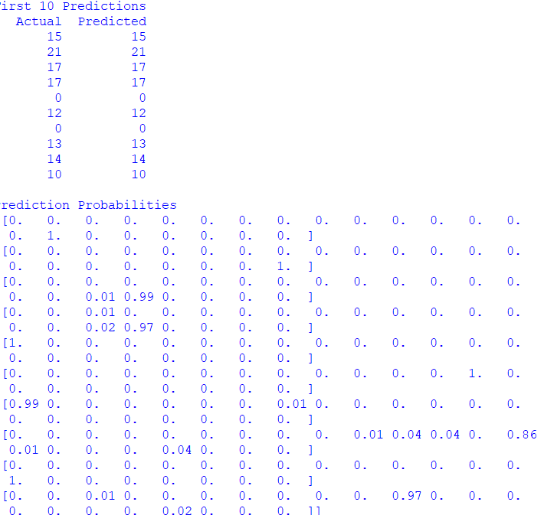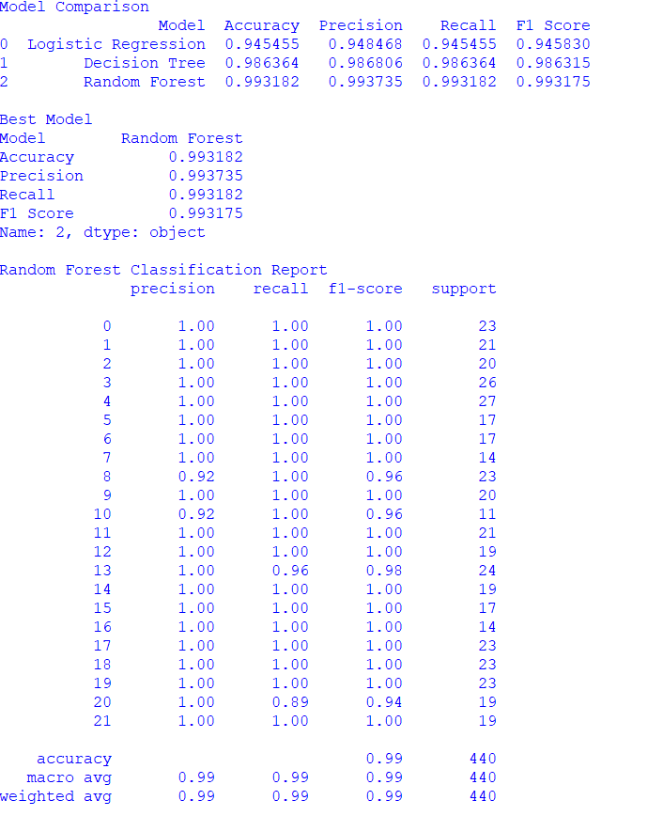

SECTION 4 — PROBLEMS FACED & HOW YOU SOLVED THEM

Error / Problem (e.g. ValueError when scaling — solved by dropping nulls first)
Model training was slow on large data
Categorical data could not be processed

How I Fixed I (Describe your solution or what help you took)

Used a train-test split and optimized model parameters.

Applied LabelEncoder to convert text data into numerical values.

SECTION 5 — PLAN FOR TOMORROW

What will you do tomorrow? (e.g. Train Random Forest, compare with Logistic Regression, start Flask app)
Hyperparameter
Tuning

SECTION 6 — LINKS & ATTACHMENTS

GitHub Repo / Commit Link | https://github.com/rtarun7879-byte/Veltech-Summer-Internship.git
Model Result / Colab Link
Deployed App Link (if any)
Additional Notes

SECTION 7 — SELF RATING FOR TODAY

Area | 1 | 2 | 3 | 4 | 5
Understanding of today's concept | ☐ 1 | ☐ 2 | ☐ 3 | ☐ 4 | ☐ 5
Hands-on coding confidence | ☐ 1 | ☐ 2 | ☐ 3 | ☐ 4 | ☐ 5
Progress on my project | ☐ 1 | ☐ 2 | ☐ 3 | ☐ 4 | ☐ 5
Overall satisfaction with today | ☐ 1 | ☐ 2 | ☐ 3 | ☐ 4 | ☐ 5

